**Project Design Phase-II**

**Data Flow Diagram & User Stories**

|  |  |
| --- | --- |
| Date | 27 JUNE 2025 |
| Team ID | LTVIP2025TMID31213 |
| Project Name | EDUTUTOR-AI-PERSONALIZED-LEARNING-  WITH-GENERATIVE-LMS-INTEGRATION |
| Maximum Marks | 4 Marks |

**Data Flow Diagrams:**

**Example:** [**(Simplified)**](https://developer.ibm.com/patterns/visualize-unstructured-text/) **User Stories**

A Data Flow Diagram (DFD) is a traditional visual representation of the

information flows within a system. A neat and clear DFD can depict the

right amount of the system requirement graphically. It shows how data

enters and leaves the system, what changes

the information, and where

data is stored.

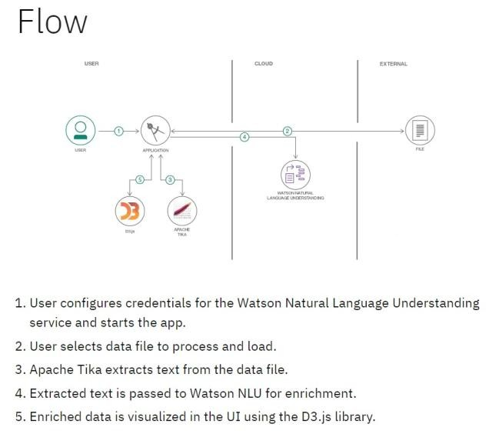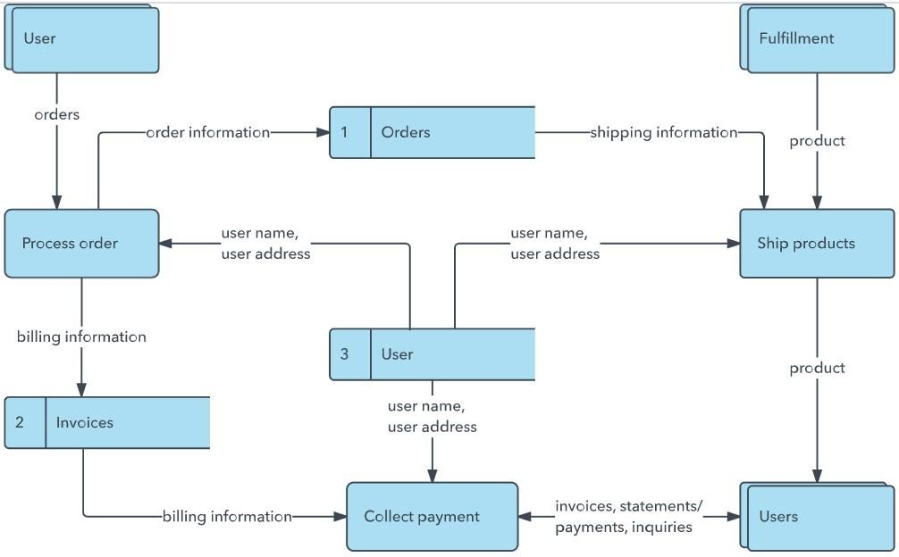

Use the below template to list all the user stories for the product.

|  |  |  |  |  |  |  |
| --- | --- | --- | --- | --- | --- | --- |
| **User Type** | **Functional**  **Requirement**  **(Epic)** | **User Story**  **Number** | **User Story / Task** | **Acceptance criteria** | **Priority** | **Release** |
| Customer  (Mobile user) | Registration | USN-1 | As a user, I can register for the application by entering my email, password, and confirming my password. | I can access my account / dashboard | High | Sprint-1 |
| tutor | Registration | USN-2 | As a user, I will receive confirmation email once I have registered for the application | I can receive confirmation email & click confirm | High | Sprint-1 |
| Student | Tutor search & Booking | USN-3 | As a user, I can register for the application through Facebook | I can register & access the dashboard with Facebook Login | Low | Sprint-2 |
| Student | Tutor search & Booking | USN-4 | As a user, I can register for the application through Gmail | **Given** I’m on the registration page, **When** I submit valid info, **Then** I should see a confirmation and be logged in. | Medium | Sprint-1 |
| Tutor | Login | USN-5 | As a user, I can log into the application by entering email & password | **Given** I provide documents, **When** they  are approved, **Then** my tutor status is activated and I get notified. | High | Sprint-1 |
| Student/Tutor | Dashboard | US-E3-01 | As a **student**, I want to register so I can create an account | **Given** I’ve entered filters, **When** I search, **Then** I see a relevant list sorted by rating/availability. | Medium | Spirint-1 |
| Customer (Web  user) | Video Session & Feedback | US-E3-02 | As a **tutor**, I want to register and verify credentials to be listed | **Given** I select a tutor & time, **When** I confirm booking, **Then** the system reserves slot and sends | high | Spirint-1 |
|  |  |  |  | confirmation with payment instructions. |  |  |
| Customer Care Executive | Video Session 7 Feedback | US-E4-01 | As a **student**, I want to search tutors by subject & grade level | **Given** a new booking arrives, **When** I click Accept or Reject, **Then** the student and tutor receive corresponding notifications. | Medium | Spirint-1 |
| Administrator | Notifications | US-E3-01 | As a **user**, I want to get email reminders before a session | **Given** session start time arrives, **When** I click “Join Session”, **Then** the video opens and both parties connect. | Low | Spirint-1 |
|  |  |  |  |  |  |  |
|  |  |  |  |  |  |  |
|  |  |  |  |  |  |  |